Travel report

Event: General Assembly 2019 of the European Geosciences Union (EGU)
Place: Vienna – Austria
Date: 7–12 April 2019
The EGU General Assembly is the most conference about geochemistry in Europe. In this year was 5,531 oral presentations and 9,432 posters. The fluvial sediments have the capacity to concentrate chemical components and thus act as a sink for pollutants in the environment. Sediment monitoring is expected to offer cost efficient alternatives to conventional water monitoring for Hazardous Substances listed in EU Water Framework Directive (WFD), Guidance Document Nº 25. My poster evaluated the mobility of trace elements (As and Pb) and major elements (Fe, Al, Mn and S) in stream and floodplain sediments as contamination receptors, and waste rock and rock formations as contamination sources in the catchment located at the historic Baiut mining area in Romania.
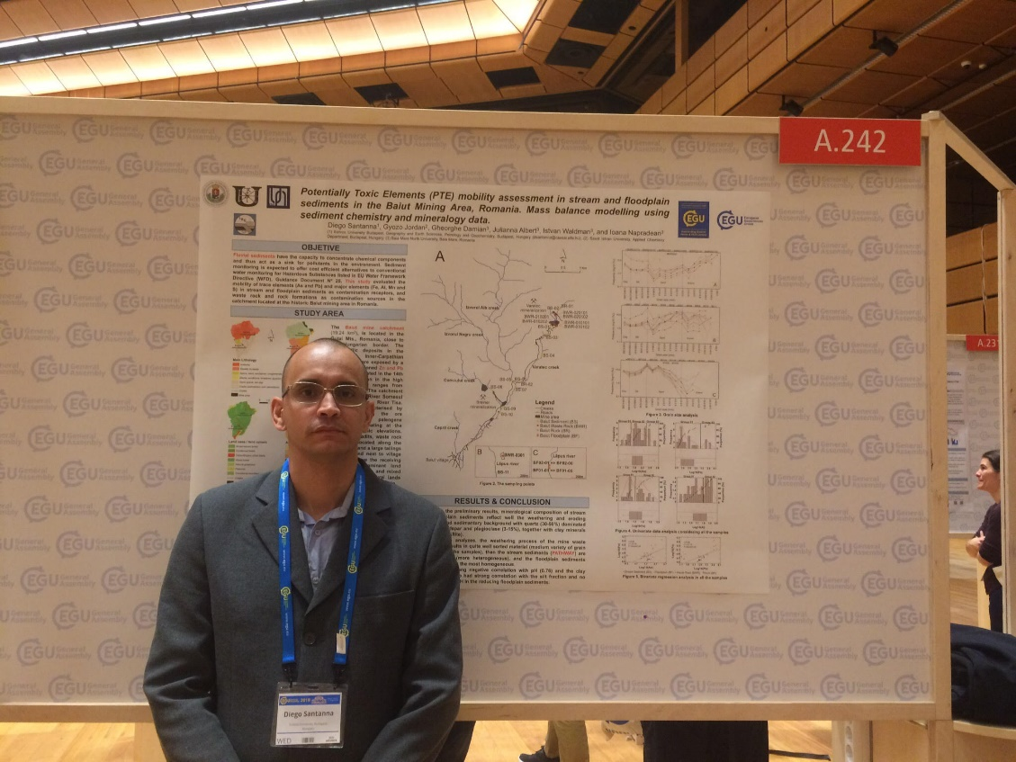

Budapest, 2019.05.27
Diego Magalhães Borges Santanna

